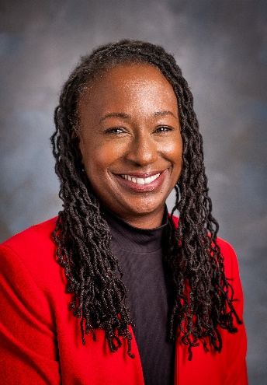

Arkansas Blue Cross and Blue Shield is an independent licensee of the Blue Cross and Blue Shield Association.

Dr. Creshelle R. Nash, M.D., M.P.H., is the medical director for Health Equity and Public Programs at Arkansas Blue Cross and Blue Shield. In this role, Dr. Nash provides leadership for developing, implementing, and evaluating health equity initiatives to help create a more inclusive and non-discriminatory healthcare system throughout Arkansas.

Dr. Nash provides oversight and guidance on public programs and products to improve health equity for all Arkansans. This role includes a position on the leadership committee for the *Vaccinate the Natural State* initiative*,* a combined effort from a diverse set of organizations working to increase the adoption of COVID-19 vaccines across Arkansas and ensure equitable access and distribution. Dr. Nash is passionate about addressing health disparities in Arkansas’ most vulnerable communities and takes action as a leader throughout the state.

In addition to her role at Arkansas Blue Cross, Dr. Nash serves as a consultant for Community Engagement and Social Determinants of Health and Equity at the University of Arkansas College of Public Health, where she is also the co-director of the Racial and Ethnic Health Disparities Service Learning Course.

Prior to her work with Arkansas Blue Cross, Dr. Nash served as the medical director for the Arkansas Minority Health Commission, where she developed and implemented community outreach programs and partnerships.

Dr. Nash completed medical school at the University of Maryland School of Medicine in Baltimore, MD, and served her residency in the Primary Care Internal Medicine Residency Training Program at George Washington University Hospital in Washington, DC. She received a Master of Public Health degree from Harvard University School of Public Health and completed a fellowship in Minority Health Policy from Harvard University School of Public Health, also in Washington, D.C.

Creshelle R. Nash, M.D., M.P.H

Medical Director for Health Equity and Public Programs

Arkansas Blue Cross and Blue Shield

CERTIFICATIONS

American Board of Internal Medicine  
Board Certified, 1999, 2015

Licensed Physician, State of Arkansas  
#E-1980 (active) October 1998

Controlled Substance Registration Certificate December 1998

Licensed Physician   
Commonwealth of Virginia, October 1998

EDUCATION

Fellowship in Minority Health Policy   
Harvard University School of Public Health

Master of Public Health   
Harvard University School of Public Health

Primary Care Internal Medicine Residency George Washington University Hospital

Medical School   
University of Maryland School of Medicine

Bachelor of Science in Biology   
Rhodes College

To schedule an interview with Dr. Nash, or for more information, contact:

**MEDIA CONTACT**

Alison Melson, APR   
Vice President of Corporate Marketing  
Arkansas Blue Cross and Blue Shield

(501) 378-3217

Email